EOC REVIEW SESSION – EXIT SLIP NAME: _____________________________

1. 

2. Give the equation of the quadratic with a zero of 5*i*.

3. Micah is writing a function that models the height a dolphin reaches when it propels itself from underwater to the surface, leaps through the air, and reenters the water. The model is represented by the equation $h=-16t^{2}+96t-128$ where $h$ is the height in feet above the surface of the water and $t$ is the time in seconds. According to Micah’s model, how long will the dolphin be above the surface of the water?

4. Functions *f* and *g* are graphed below.

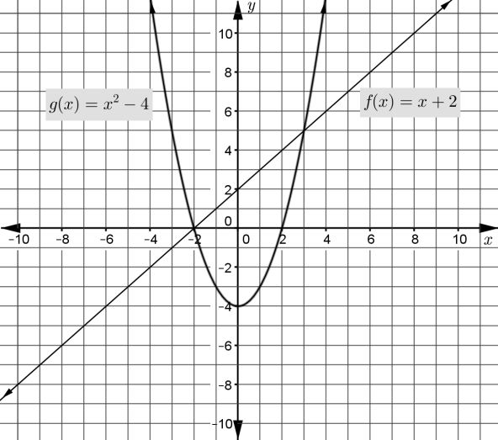

Use the graph to find the solution(s) of the equation $f\left(x\right)=g(x)$. Explain how you found the solution(s).