Algebra 2 EOC Review
April 7, 2015 Exit Slip
1. Prove the equation below is true x = - $\frac{1}{2}$.
$\frac{4x^{2}}{2^{x}}$ = 2

2. What is the least common denominator of $\frac{3x}{x+1}$ + $\frac{x+1}{2x }$ + $\frac{5}{x }$ ?

3. 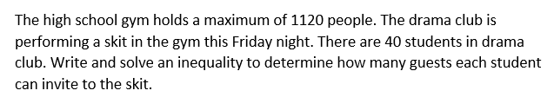

4. Find the quotient and remainder for the rational expression $\frac{x^{3}+ {-3x}^{2 }+ x-6}{x^{2 }+ 2}$

Answers to Exit Slip.
1. 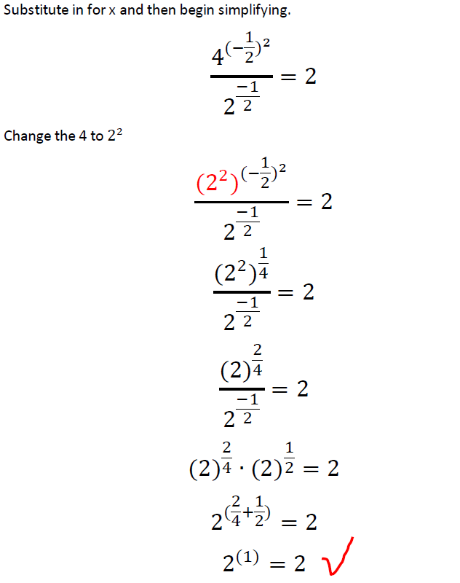

2. 2x(x + 1)

3.
Since the gym will hold a maximum of 1120 people, the number of guests and students must be less than or equal to 1120.
Let g represent the number of guests.
The inequality would be
40 + 40g ≤ 1120 40 students + 40 times the number of guests per student
-40 -40 Solve by first subtracting 40 from each side
40g ≤ 1080
40 40
g ≤ 27 Each student can invite a maximum of 27 guests.
X – 3 - $\frac{x}{x^{2 }+ 2}$
4. x² + 2 x³ – 3x² + x – 6
-(x³ + 2x)
-3x² – x – 6
-(-3x² - 6 )
- x

