Practice Test - Get used to the new EOC format!
5. Select your grade level then click “yes”
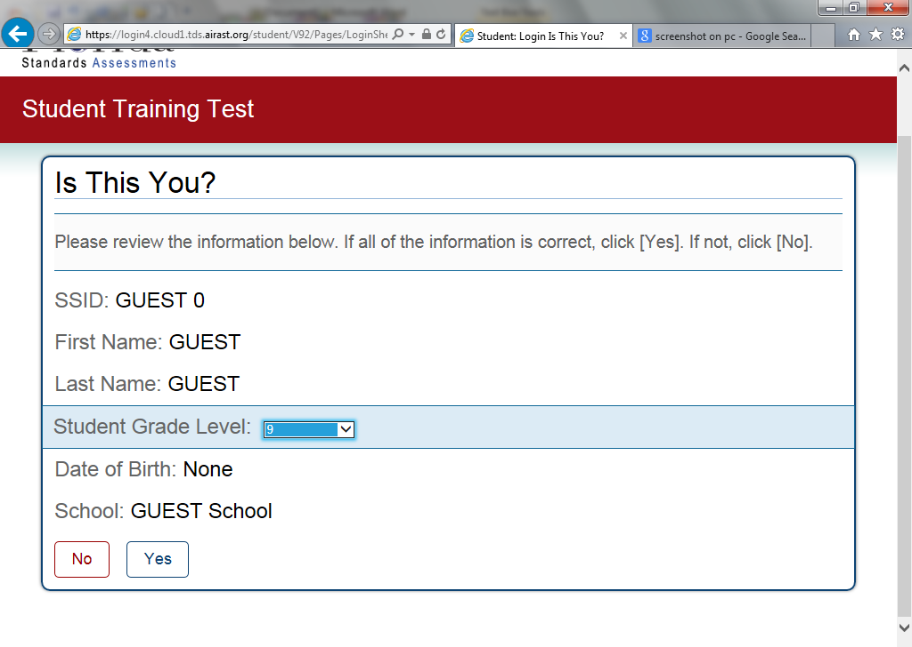
6. click “Start FSA Infastructure trial test”
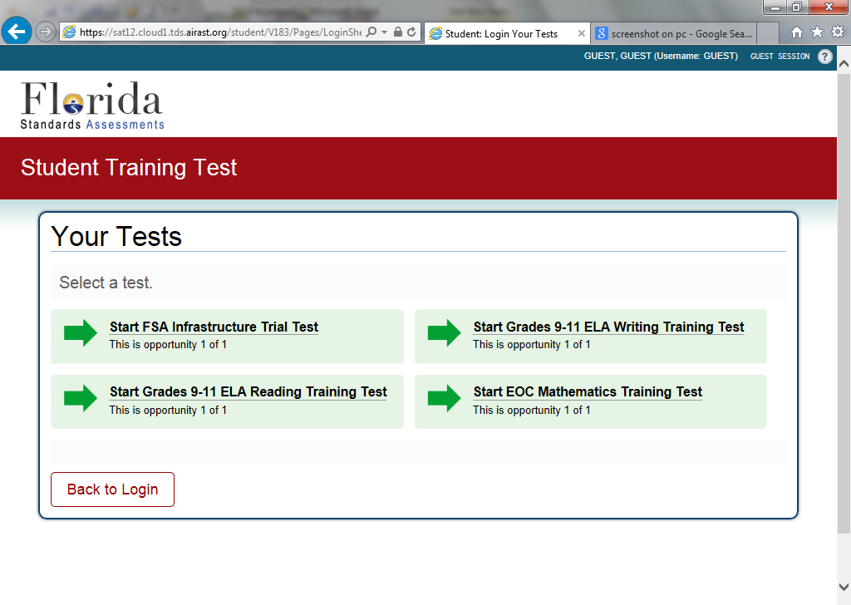
7. Click “select” (don’t change settings)
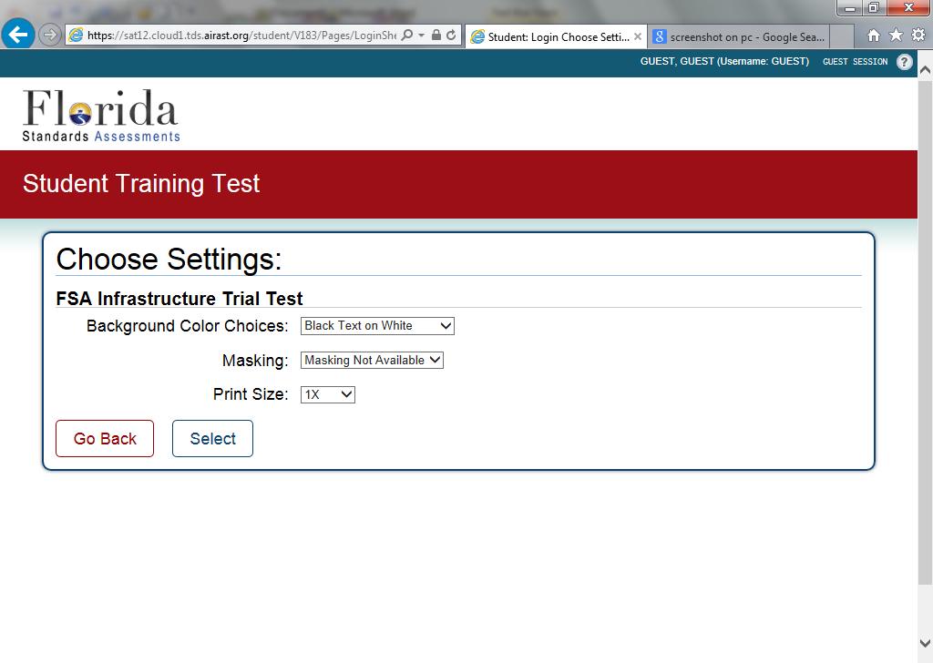
8. Click “yes start my test”
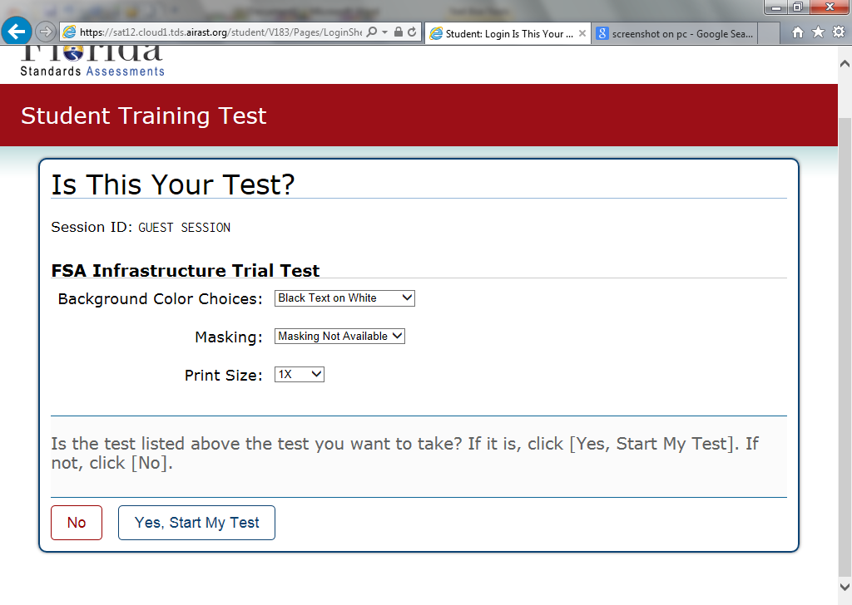
MORE ON BACK ------
Go to www.fsassessments.org
1. On left of screen – click on “Students and parents”
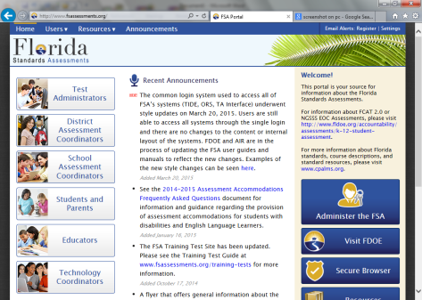
2. Click on training tests
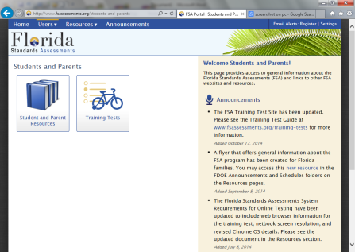
3. click on “Take the computer based training test”
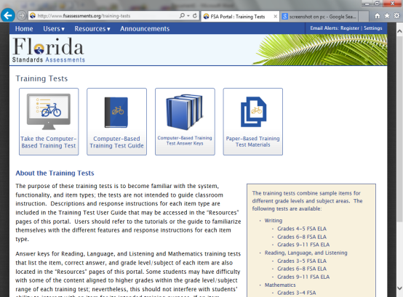
4. You don’t have to enter any information – just
click “sign in” to sign in as a guest.
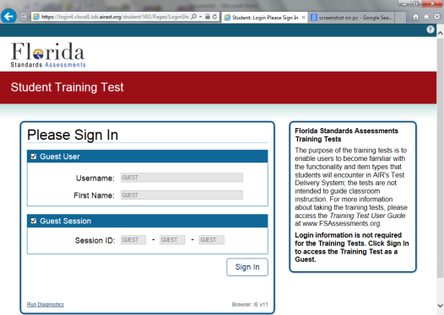

9. Read over this page. It will describe the layout of the screen during testing. When you are finished reading, scroll down to the bottom and click “begin test now”
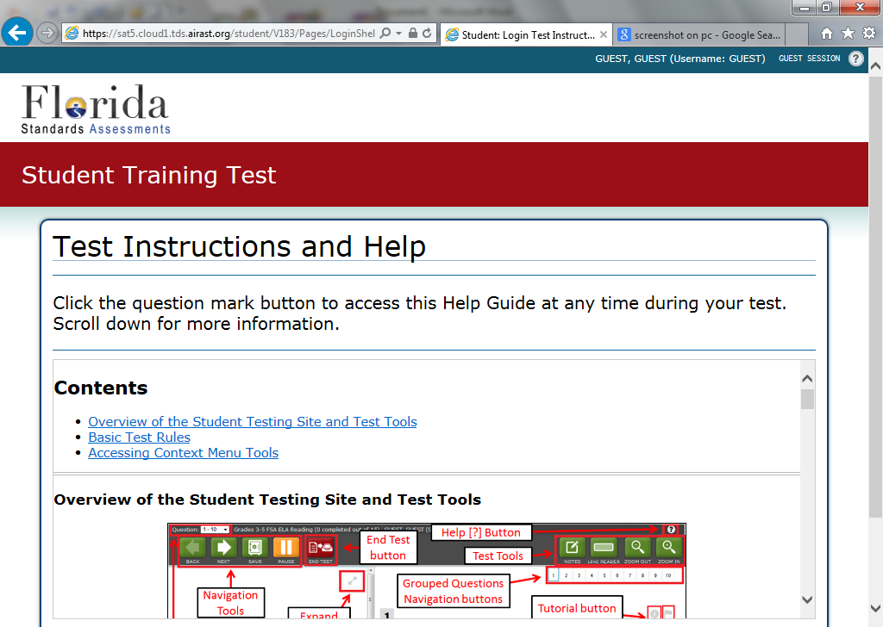
10. There are 56 questions on the practice test. The math is below Algebra I level. I am not interested in whether you get the questions correct, I just want you to have some experience with the testing software. You do not have to do all 56 questions, I would like you to complete at least 20. When you finish 20 questions you can click on “end test”. You will then get a screen that looks like this:
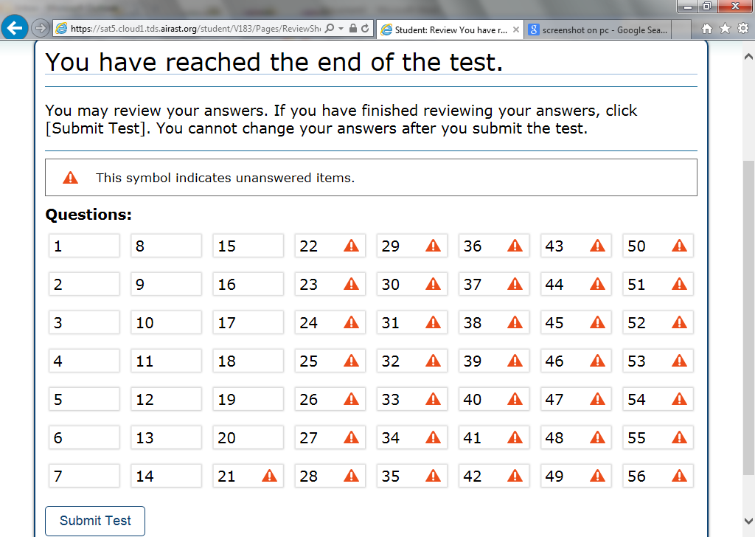
The blanks show that you did that problem.
This activity will count as a 20 point quiz grade. It is due by April 17th. You can turn it in 2 different ways:
1) print the page above “You have reached the end of the test” , write your name on it and turn it in to me.
2) take a screen shot of the page above and email it to me at dpharvey@oneclay.net Please put your name and period in the subject line.

